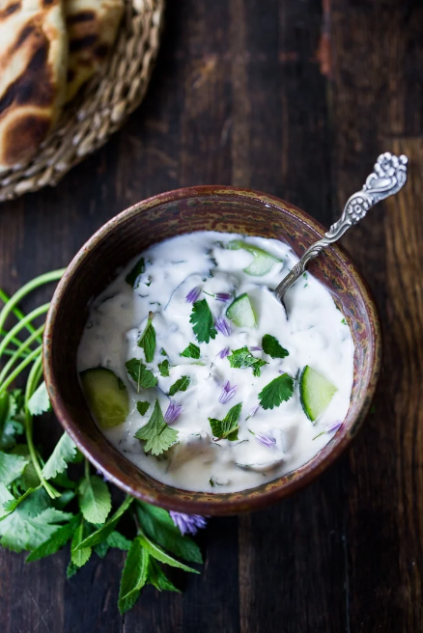
Raita

INGREDIENTS

- 800g Greek yogurt
- 1 garlic clove (optional)
- thumb-sized piece ginger, finely grated (optional)
- a pack coriander, chopped
- a pack mint leaves, chopped
- lime juice, 1 teaspoon
- 300 ml water
- 1 tsp garam masala/chaat masala, plus a little extra to serve
- 1 cucumber, grated or chopped
- 1 onion, finely chopped
INSTRUCTIONS
- Mix all the ingredients and season.

